**Lab report #5**

**Sadovskaya Veronika**

GitHub: https://github.com/sdveronika/DataMola22

**Task 1 - Create Packages for Reload Dimension from SA_\***

1. Use DBMS_SQL.TO_REFCURSOR Function

Truncate table dw_data.payment_method_dimension that was created in Lab 4 unit 2:

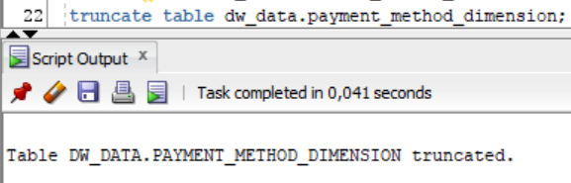

Create new procedure for moving data from cleansing layer to DW layer using the example of payment_method_dimension:

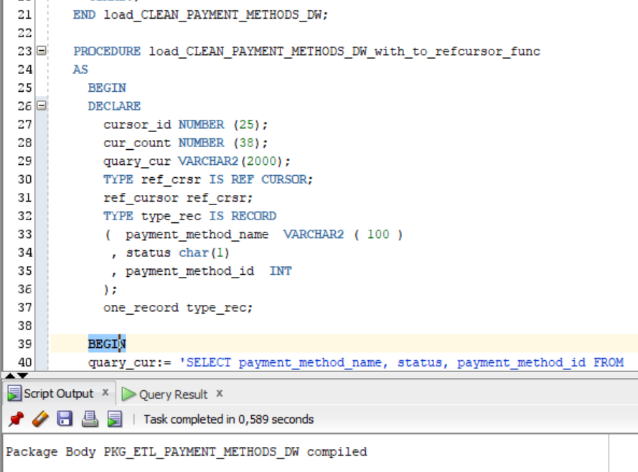

Execute new procedure:

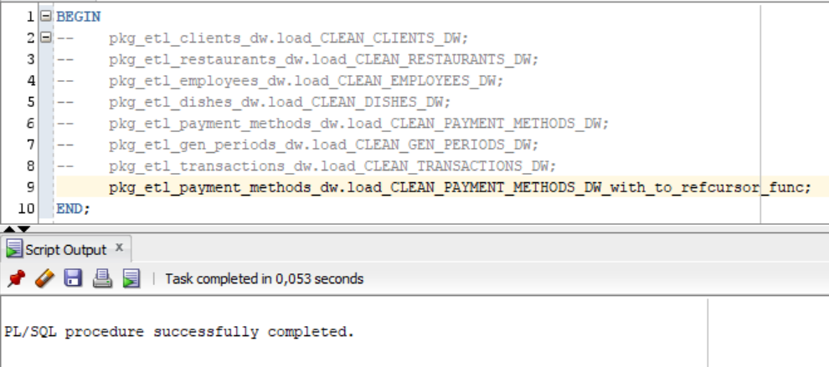

Select data from table dw_data.payment_method_dimension that was filled using the new procedure:

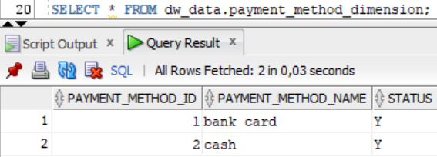

1. Use DBMS_SQL.TO_CURSOR_NUMBER Function

Truncate table dw_data.payment_method_dimension that was created in Lab 4 unit 2:



Create new procedure for moving data from cleansing layer to DW layer using the example of payment_method_dimension:

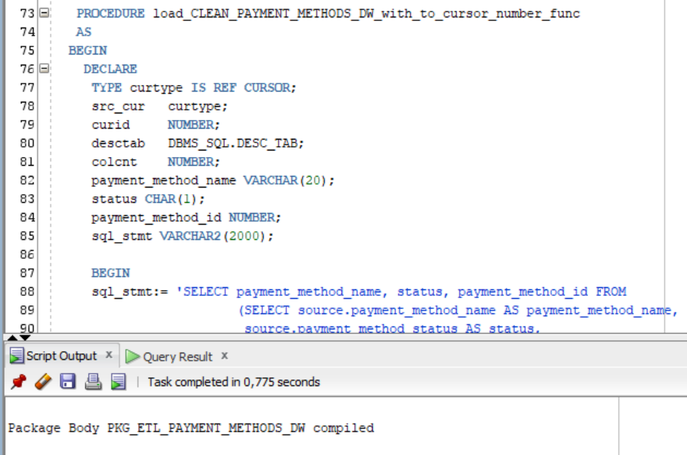

Execute new procedure:

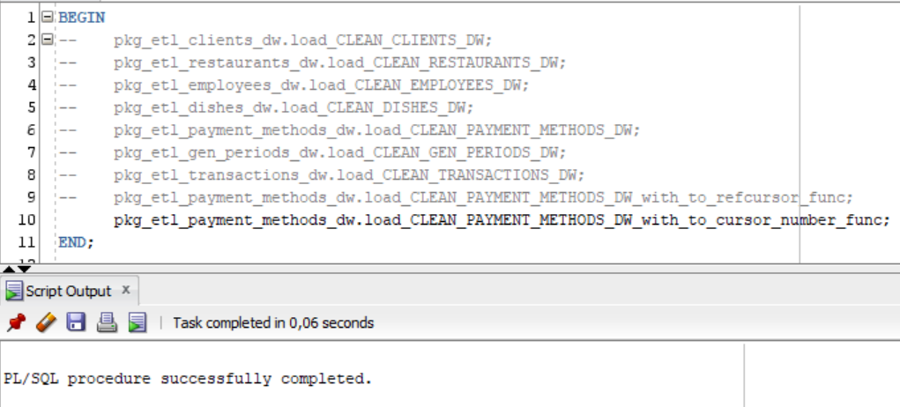

Select data from table dw_data.payment_method_dimension that was filled using the new procedure:

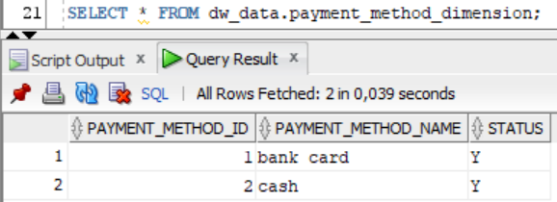

1. Use Execute Immediate with Bind Parameters

Execute Immediate was used back in lab 4 when creating a layer, when we needed to first clear the table before populating it. Example (DW_CL/clients/ pkg_etl_clients_cl_imp):

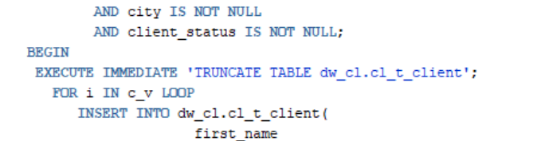

**Task 2 - CREATE** **Monthly** **Reports Layouts**

Using the model, the total number of dishes sold for each item is calculated for the year and for the entire time the restaurant has been operating.

